Calculus 1 Lecture 3.7: Optimization; Max/Min Application Problems

Maximizing/minimizing continous functions
- Closed intervals
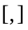 there will be a absolute maximum or an absolute minimum solution.
- Open, infinite intervals
There maybe an absolute maximum or an absolute minium solution if and only if the function has a relative maximum or a relative minimum.

Example
Fence a rectangular region and maximize the area. You have 100 feet of fence. (Constraint)

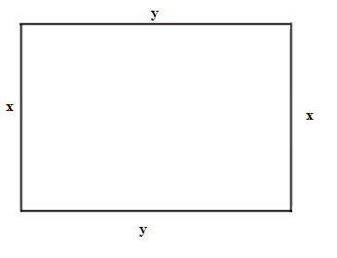
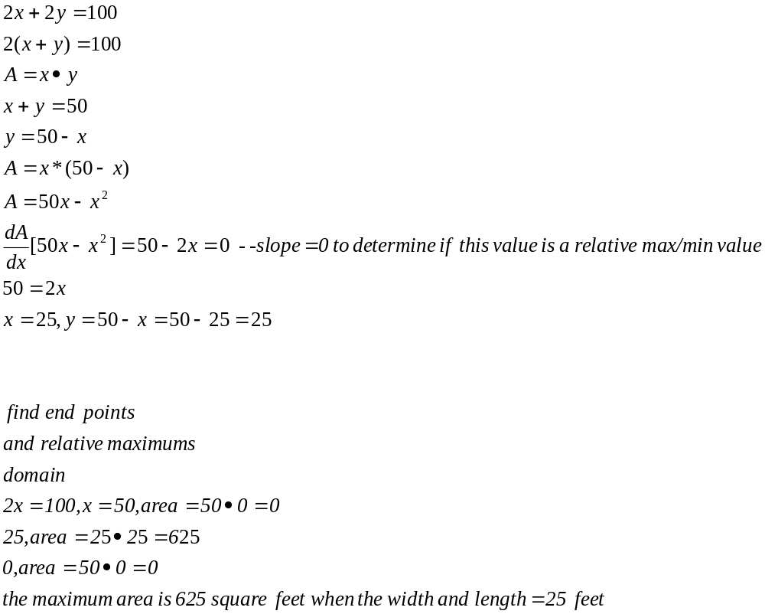

Example
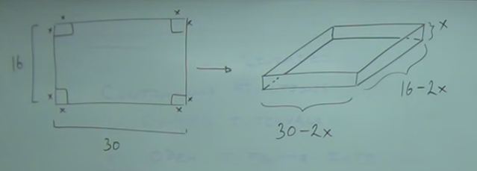

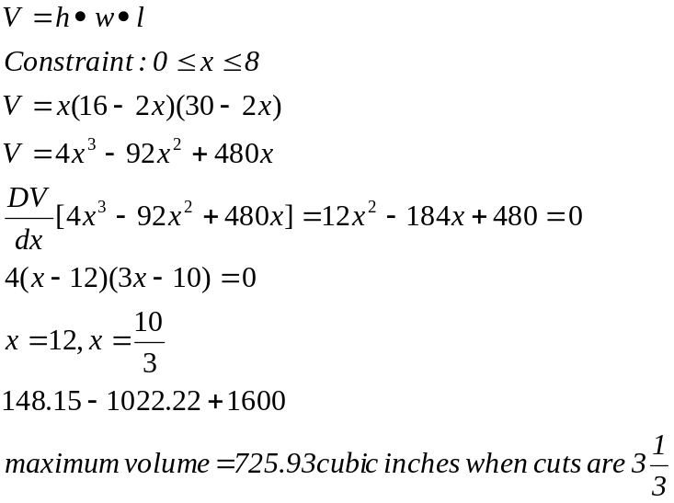

Example

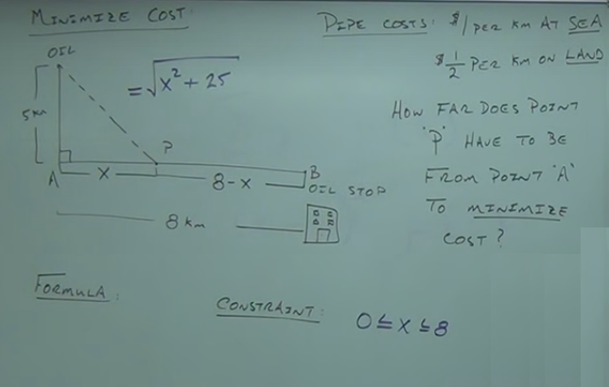

Cost=(length of pipe at sea times cost on sea) plus (length of pipe on land times cost on land)

Length of pipe at sea=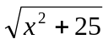
Cost of pipe at sea=1
Length of pipe on land=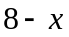
Cost of pipe on land=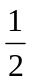

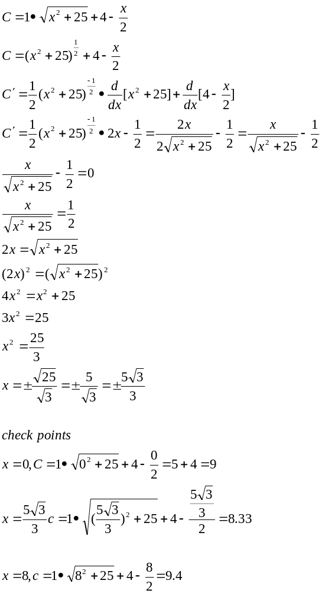

Example
A cola can needs to hold 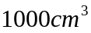 minimize the material needed

